ON SETTING SMART-TV GUIDE
Smart Hub - a proprietary technology (service), from Samsung, which is used in smart TVs to access the various multimedia applications, and management. Smart Hub service enables you to navigate both the built-in multimedia applications, as well as on the remote server.
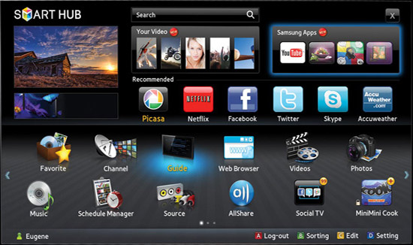

Samsung Smart Hub
The story of Smart Hub begins with 2011, then was first introduced to this technology, the first TV View Smart Hub control system can connect to Samsung apps service. TV series got the following search service, built-in web browser and Skype software to communicate on the network. In the end, it added the ability for wireless communication facilities Wi-Fi technology.
To get to the Smart Hub interface is possible by pressing the corresponding button on the remote control. One of the main pieces of this technology is the possibility of a functional service management via mobile devices based on Android or IOS operating system. Social TV Function - allows you to view videos or TV shows and talk at the same time on social networks. Shop apps Samsung Apps has a wide assortment of applications, the main sections of the store: video, games, sports, style, information and education opportunities. You can set a password on folders and individual applications (parental control).
on setting SMART-TV SAMSUNG Guide
Information provided by the site Xsoid.ru
1. Connect your TV to the Internet. The TV must be behind a router! The router must be configured to work with the Internet and packet network speed, the subscriber must be not less than 20 Mb / s.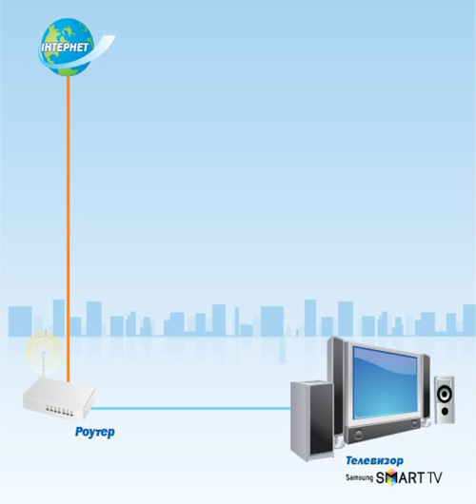
2. Turn on the TV, then press the "SMART", to go to the menu "SMART HUB"
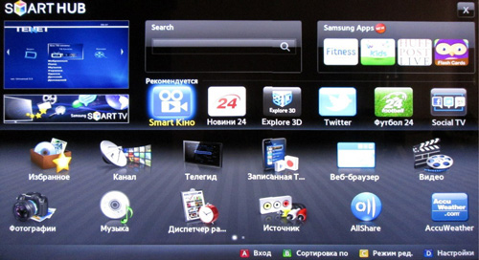
3. Register the Smart TV Samsung account. In the menu "SMART HUB" push the A button on the remote control and in the "Login" window that appears, click the button "Create. Uch. Zap.".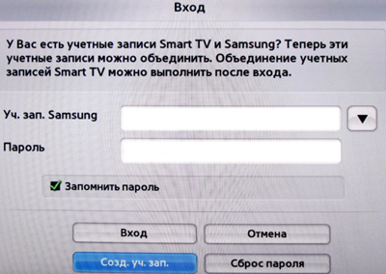
4. Accept the "Terms. agreement. maintenance "(to create a new account. Entries)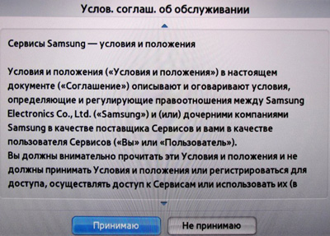
5. After the adoption of the conditions of the service agreement, the window "Create. Uch. Zap."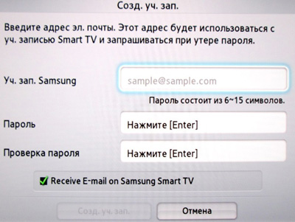
6. Enter the data: a) in a row. ". Ouch zap the Samsung" push button (Enter). Data is entered using the keyboard.
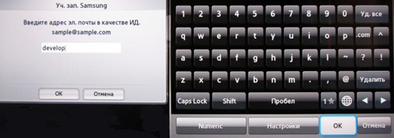
Enter "the develop" and confirm "OK" button; b) In the line "Password" and "Verify Password" using the on-screen keyboard, enter any password between 6 and 15 characters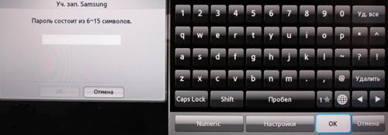
and confirm with the "OK"
put a tick 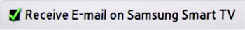
and press the button 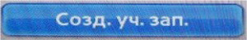
The message "Ouch. Develop a record is created. Continue?" Click "OK". "Develop" Account created in Smart TV.
7. Select the Smart TV Samsung account. After account creation screen appears "Login", select the account you just created "the develop", enter the password, put a tick and press the input button.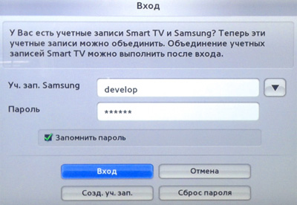
8. Set up sync with TENET-TV. The "SMART HUB" menu of the TV press the D button on the remote control, and in the pop-up window "Settings" select "Development" and press (Enter) button
(Some TV firmware versions to open the window "Settings" use "TOOLS" button)
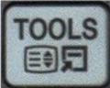
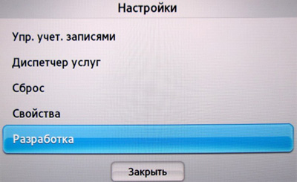
9. Then select the "Setting IP-addresses serv." and press (Enter) button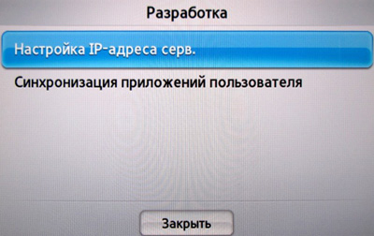
Enter the IP-address to sync with the "Smart Hub": 195.138.78.68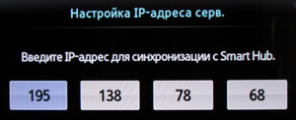
press (Enter) button - confirm and select "Synchronize user applications."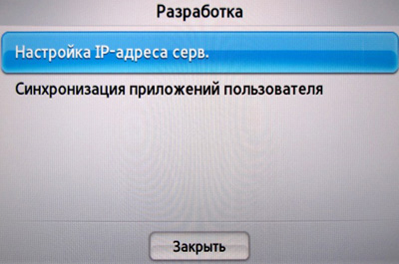
After successful synchronization of the on-screen message should appear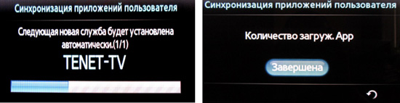
confirming the successful addition of new TENET-TV applications. We leave the menu «SMART HUB» and select TENET-TV widget
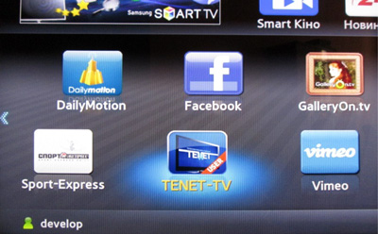
Note: To display the widget TENET-TV, double-press the "SMART" TV remote control (on / off TV.).
10. To register your TV.
If your TV is not registered, the screen registration form will appear.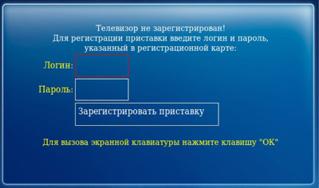
To register, please enter in the corresponding rows login and password for Internet connection, specified in the registration card (form №5, issued together with a set of documents in the contract). To enter a login on the selected field, press the key and use the screen keyboard to enter a login, press the "close". To enter the password on the selected field, press the key and use the screen keyboard to enter the password, press the "close".
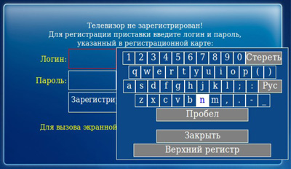
After entering the login and password, click "Register TV." If username and password are correct, the TV will check in 1-2 seconds. When filling out the fields make a mistake when you try to create the message "Wrong username or password!"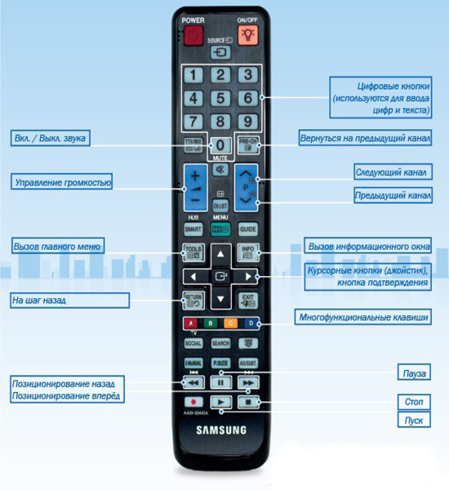
Meaning Clavey key on the remote control.

